ICS3U Culminating

Aladdin- Vashista Gande

**Problem Definition:**

For the final project I have decided to develop a videogame using all the concepts learned in this course throughout the semester such as arrays, system IO, functions, methods, etc. The purpose of this assignment was to test my abilities and skills learned over the course. I have encountered with various problems while making the game “Aladdin The Great”. One of biggest problem I had with the game is that, I wasn’t able to transparent the backgrounds for images, this ruins the enjoyment of the game, even though with the use of GDI, I couldn’t eliminate the problem. Another problem I faced is that sin movement of the hard difficulty, in this coins fall in sin curves, I have been able to solve with a revised sin wave formula.

**Variable Dictionary:**

1. ***Significant Global Variables***
   1. PictureBox picMat;
   2. PictureBox picJeene;
   3. PictureBox[] picGoldCoin = new PictureBox[6];
   4. PictureBox[] picRedGoldCoin = new PictureBox[6];
   5. PictureBox picBoostGoldCoin;
   6. static bool blnEasy = LevelSelect.variables;
   7. public static int intScore;
   8. static int intLife;
   9. public static int intGameCounter;
   10. public static string strName;
2. ***Class Names***
   1. Intro.cs – Starting Point
   2. HighScore.cs – Display Saved High scores
   3. Instructions.cs – Shows how to play the game
   4. LevelSelect.cs – Select level difficulty between 2 modes and add name to out in high score
   5. MainGame.cs – Where the actually game takes place
   6. GameOver.cs – Shows up when the game ends
3. ***Significant Variable Usage***
   1. PictureBox picMat; :- Controlled by the player using the arrow keys, it is used to collect coins in MainGame.cs.
   2. PictureBox picJeene; :- Displays jeene, which helps users in the easy level to collect coins
   3. PictureBox[] picGoldCoin = new PictureBox[6]; PictureBox[] picRedGoldCoin = new PictureBox[6]; PictureBox picBoostGoldCoin; :- These three variables are used to drop coins from the top of the screen, using void functions and static functions.
   4. static bool blnEasy = LevelSelect.variables; :- This variable decide the diffulty of the game, based on user input, and outputs respective results.
   5. public static int intScore; :- This variable keeps track of the score, whenever the coin is collected, it is programed to be in the timer so that it whenever the coin touches the mat, the score goes up by one.
   6. static int intLife; :- This variables is used to decide the life time of the game, whenever a red coin is collected, the value of intLife goes up, and the heart on the screen goes down, when this variable reaches 3, game ends.
   7. public static int intGameCounter; :- This variable is situated in the timer and increases its by one every time the timer goes on, this keeps track of the time of the game for high score.
   8. public static string strName; :- This variable is entered by the user in the LevelSelect.cs, this is used to customize the high scores.

**Notable Function IPO:**

static double doSinCalc(int yval)

* Input – Takes in a picturebox’s y coordinate
* Process – Uses x=sin(y) to return a the picturebox’s new x coordinate so that it appears that if the picturebox is moving in a sine wave from top to bottom
* Output – Returns the picturebox’s new x coordinate

public void score()

* Takes in picture boxes for score and life
* The picture is taken from the resource file

Uses GDI to output them at specific location

public void checkWin()

* Uses counted loop, to check if the coins have touched the mat, or the bot at the bottom
* Adds up the score, life or speed, respective of the coin to the mat and the user
* Resets the location of the coins, so that they can come again

public void boostCoinFall()

* Takes in picture boxes for boost coin
* The picture is taken from the resource file
* Uses GDI to output them at specific location

public void redCoinFall()

* Uses counted loop to output all the images
* Takes in picture boxes for red coins
* The picture is taken from the resource file
* Uses random function to determine the xValue
* Uses GDI and randomized xValue to output them at specific location

public void coinFall()

* Uses counted loop to output all the images
* Takes in picture boxes for gold coins
* The picture is taken from the resource file
* Uses random function to determine the xValue
* Uses GDI and randomized xValue to output them at specific location

public void drop()

* Based on the user, input of the difficulty of the levels
* Movement of the coin is decided
* For easy, simple randomized, xValue is used and speed
* For hard, function doSinCalc is been used for the movement
* Also checks the winner

public void drop()

* Movement of the red coin is decided
* Simple randomized, xValue is used and speed at different timings

public void boostDrop()

* Movement of the boost coin is decided
* Simple randomized, xValue is used and speed at different timings

public void gameStart()

* Takes in picture boxes for Gold Coin, red coin, jeene(Only if the user input for the difficulty is easy)
* The picture is taken from the resource file
* Uses GDI to output them at specific location
* And also is been incorporated with the other functions

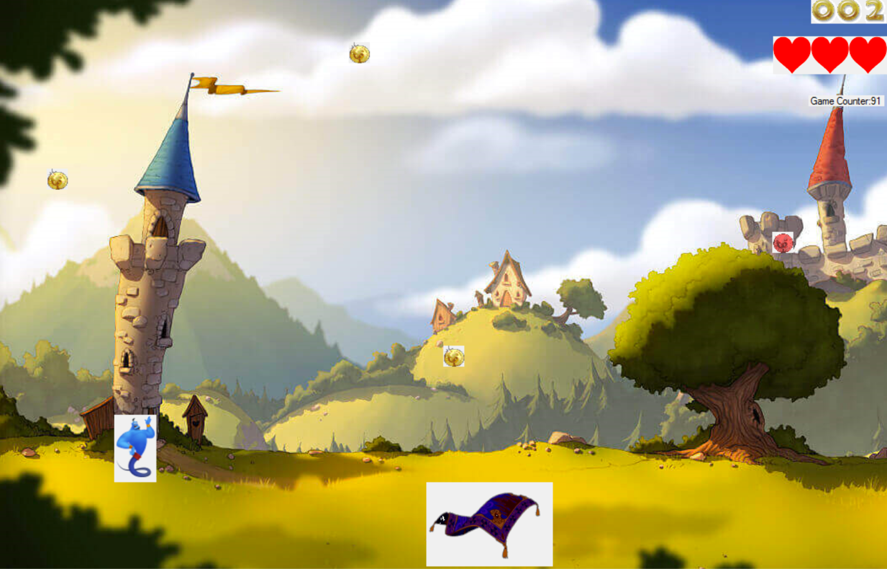**Easy:**

**Hard:**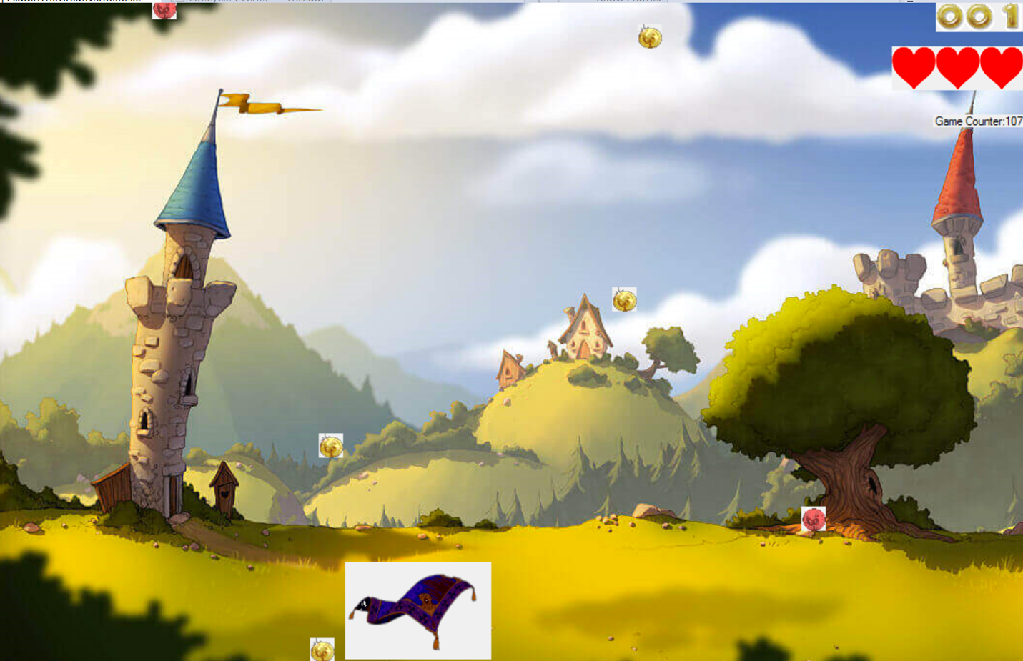

**TESTING RECORD**

|  |  |  |
| --- | --- | --- |
| Date | Testing Data | Results |
| 10rd June 2016 | Testing movement of the mat and coins for the easy level | Picturebox moves successfully but goes through the boundaries and lags |
| 11th June 2016 | Boundary Test using .left property and picBoundry and using GDI | All picturboxes react properly to the use of boundaries and successful in eliminating lag |
| 12th June 2016 | Making designs for the rest of the game, testing use of data across other forms | Responsive results, and was able to use data across forms by making it public |
| 13th June 2016 | Hard mode works with red coins falling along with the gold coins | Score works, and able use life |
| 14th June 2016 | Making and high score IO | Highscore system is functional and sorting is working |
| 15th June 2016 | Fixing the sine path for hard level | Now sin curve works and was able get score collecting coins in falling in sin curve |
| 16th June 2016 | Finishing up, final touches and testing to make sure everything is working | Game is completely functional |